How to Run the Script Katalon :

1. Add New Folder on Katalon
2. Add New Test Case on Katalon
3. Copy the Script to Katalon Tab Script

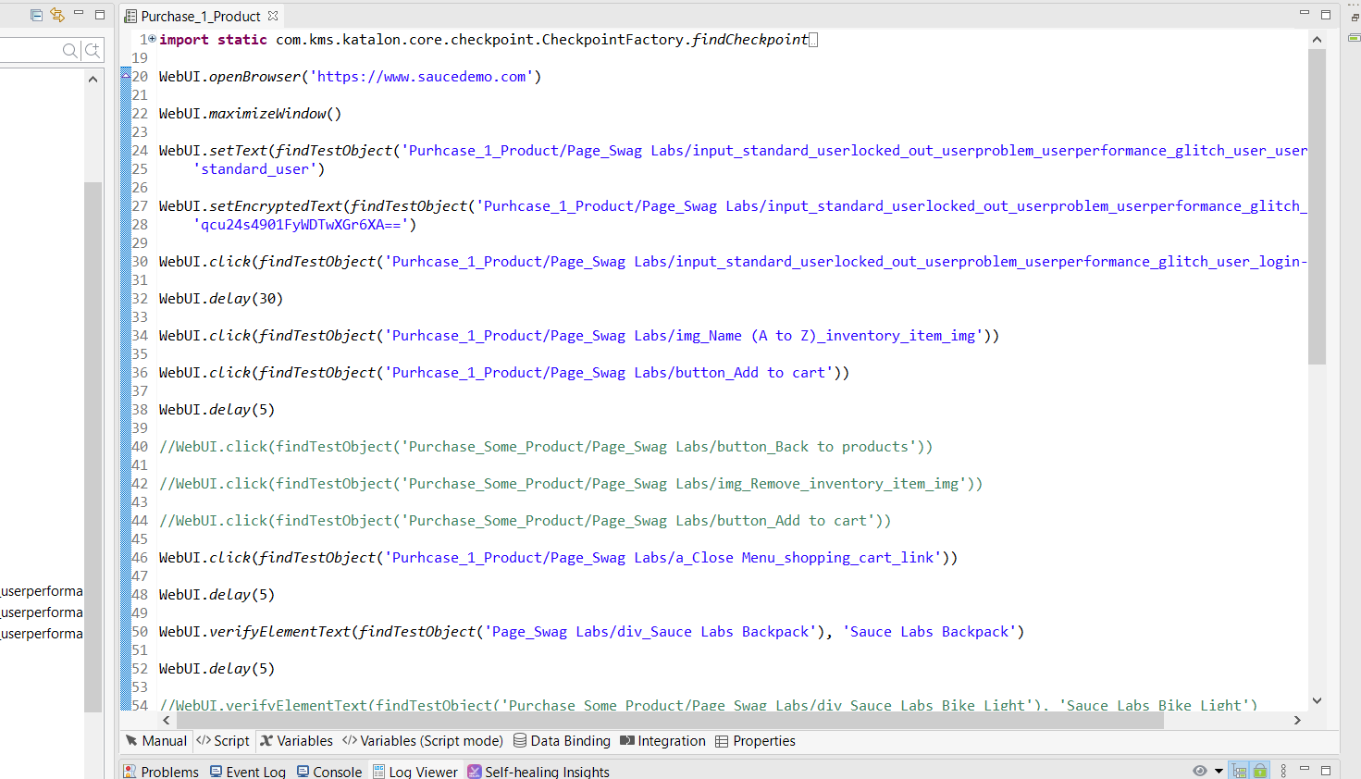

1. Choose where you want to run the script

